Rembrandt Research Grants  Project proposal |  |   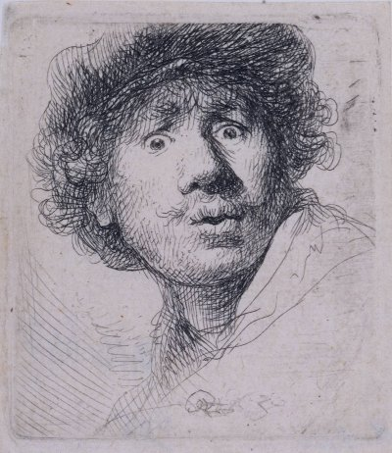 | 2024  1  Deadline: September 12th 2024, 17:00 hours
1. Applicants

2. Title of the application
3. Executive Summary (max. 300 words)

2
4. Project team | Name (title) | Discipline | Institute | Hours/week
5. Description of the research teams, self evaluation, and maximally 5 recent publications per applying PI

3
Project proposal
6. Background (max. 300 words)
7. Hypothesis (max. 100 words)
8. Objectives (max. 100 words)
9. Detailed work plan, including an overview of experiments per location (Leiden or
Amsterdam) (max 1000 words)
10. References (max. 25 references)

4

5

6

7
11. Expected outcome (max. 100 words)
12. How will the project benefit collaboration between the participating institutes? Please clearly define the synergy that is obtained.

8
13. Clinical studies | Healthy subjects yes/no  Will research be carried out with:  Patients yes/no  How many healthy subjects/patients will be involved?  Approval of the MEC: obtained/requested
14. Experimental animals | Will research be carried out on experimental animals? yes/no  Which species:  Number per year:  Type of animal model:  Approval of the DEC: obtained/requested
15. Biological hazards | Will any of the following be used:  a. recombinant DNA yes/no  b. radiation yes/no  c. radioactive isotopes yes/no  d. pathogenic microorganisms yes/no  Are you qualified to use these yes/no
16. Signature of the financial controllers | Date:  Name:  Date:  Name:
17. Signatures | Date: Applicants

